Captain Application IP
1.Captain App IP Setting
Note: If a customer has an IP address issue, in the captain app first ask the customer to check whether both devices are connected to the same internet connection or not. If the internet connection is different, ask them to connect both devices to the same Wi-Fi network and check again.
Overview: The Captain App IP Setting feature is used to configure the server IP address in the Captain App so that it can establish communication with the POS Server over the local network. This setting is typically required when the Captain App is mapped manually or when the server IP address changes.
Once the correct server IP address is configured and both the Captain device and the POS Server are connected to the same network, the Captain App can successfully sync orders, communicate with the server in real time, and perform all required operations without interruption.
Prerequisites
- Captain App Service must be activated.
- The POS Server and Captain device must be connected to the same local Wi-Fi/LAN network.
- The Server IP Address should be available.
- The POS Server should be powered on and connected to the network.

Note:If the POS is not detected automatically, first verify that both devices are connected to the same network and that the POS is online. In the latest version, the Captain App uses automatic discovery, eliminating the need for manual IP configuration.

Step 1: Open dashboard URL: billing.petpooja.com
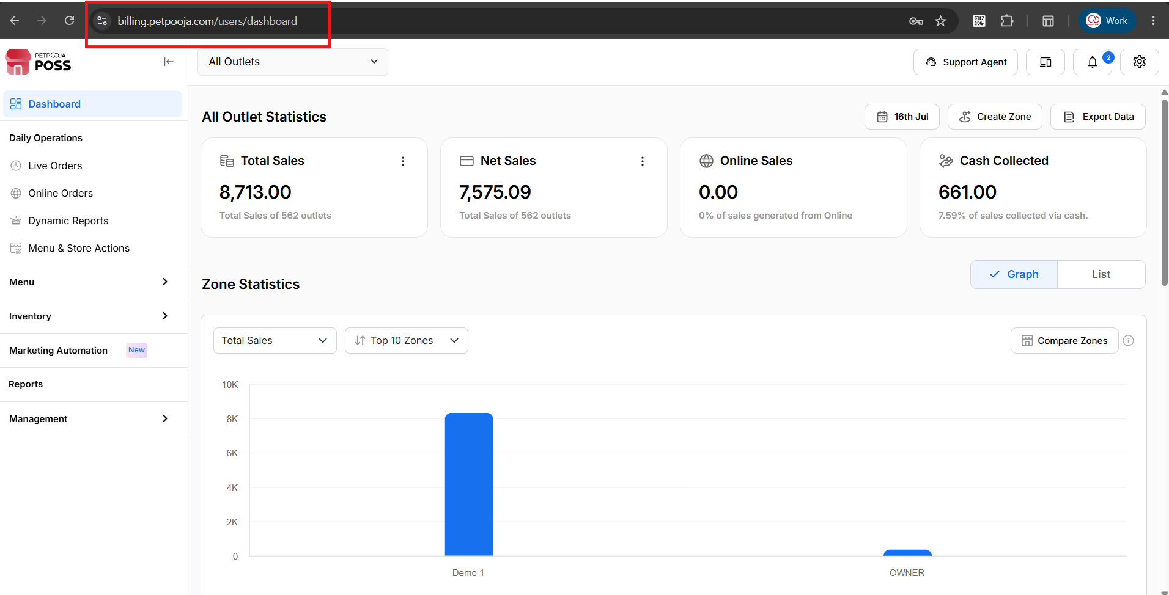
{ Image Name: After Dashboard login Page ,
Description: The highlighted section indicates dashboard URL. This is Step 1 to reach at captain IP settings page }

Step 2: Select Outlet from All Outlets dropdown list.
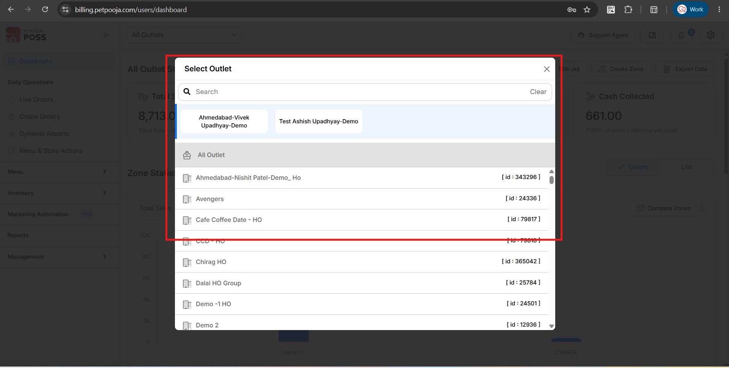
{ Image Name: All Outlet list,
Description: The highlighted section indicates Select outlet screen. This is Step 2 to reach at captain IP settings page }

Step 3: On left Sidebar click on “Management”
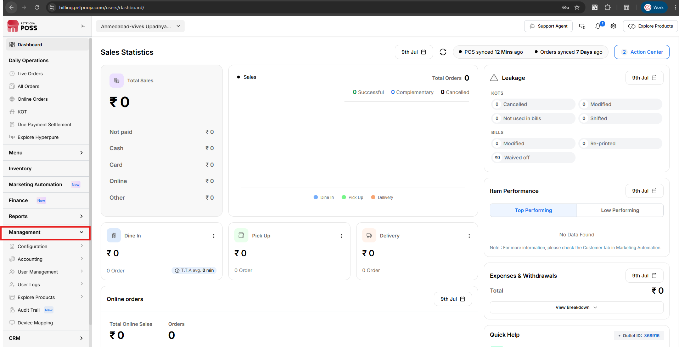
{ Image Name: Management,
Description: The highlighted section indicates tab Management. This is Step 3 to reach at captain IP settings page }
Step 3: Click on sub menu “Explore Products”
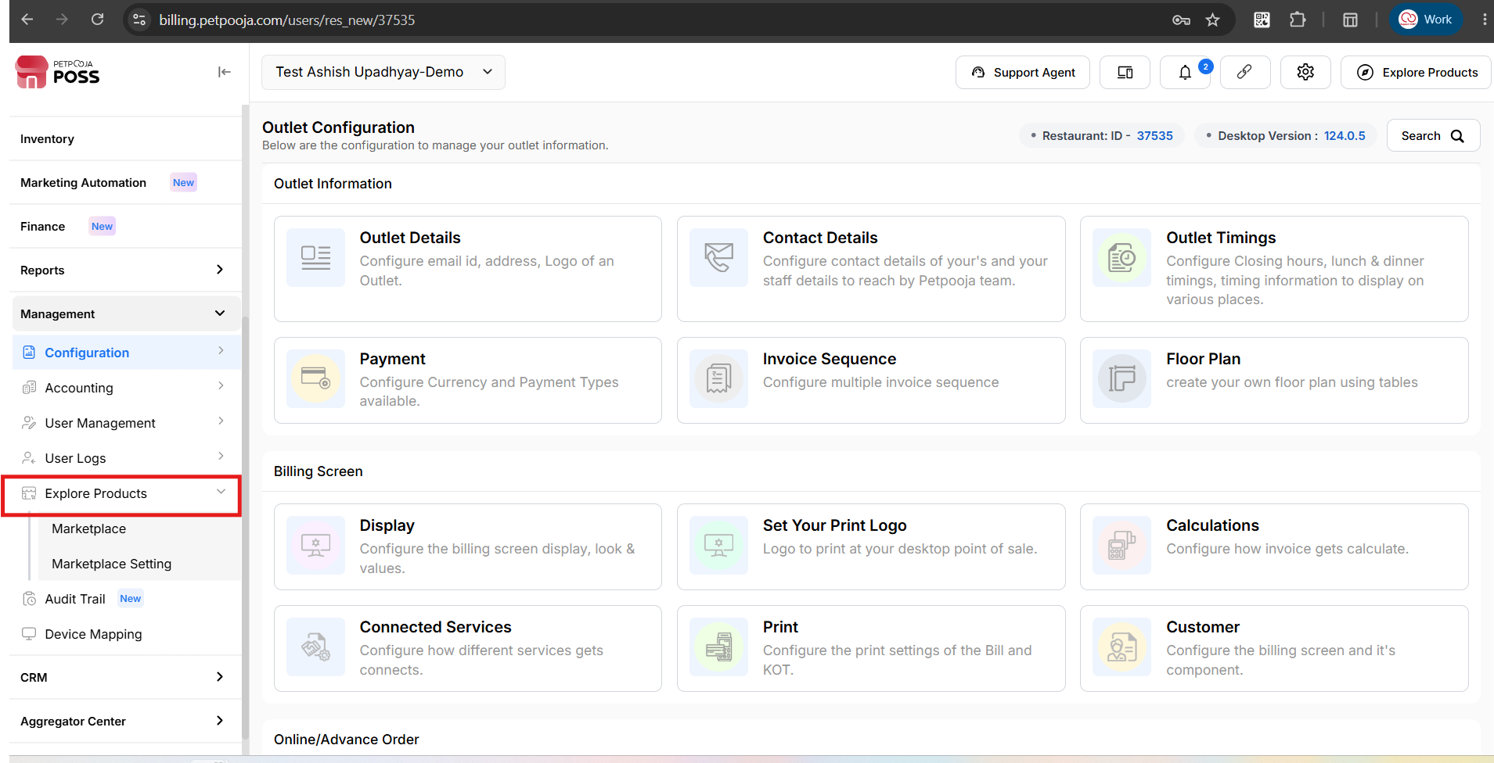
{ Image Name: Explore Products,
Description: The highlighted section indicates Explore Products .This is Step 3 to reach at captain IP settings page }

Step 4: Under Explore product section click on “Marketplace settings”
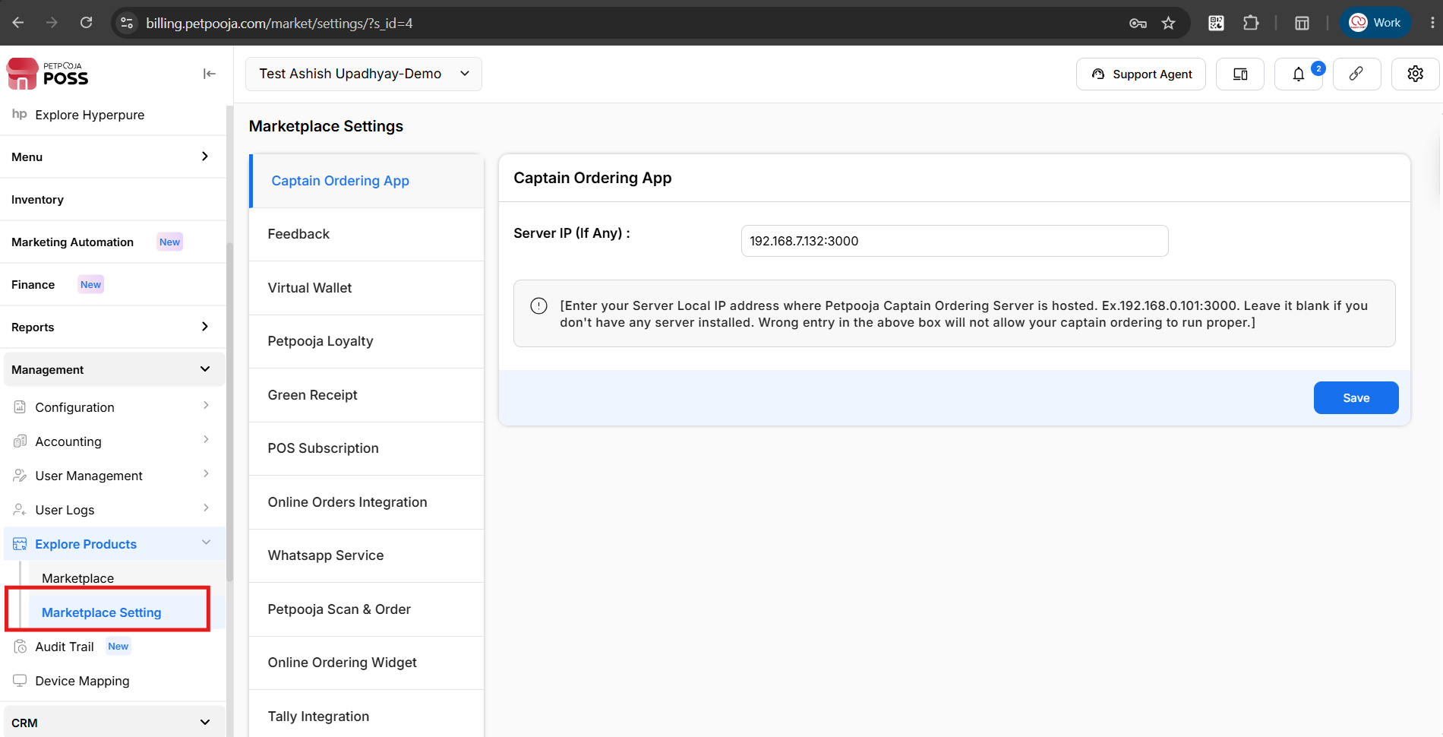
{ Image Name: Marketing Settings,
Description: The highlighted section indicates Marketing Settings This is Step 4 and last steps to set Captain IP }

2.How to find IP address from Server Computer in POS
Overview: The POS system provides a built-in option to view the Server IP Address directly from the application. This eliminates the need to use external tools or Windows network settings to identify the server's IP address Using this feature, users can quickly retrieve the Server IP Address.
Step 1: Open POS Click on Operation in the Sidebar menu section.
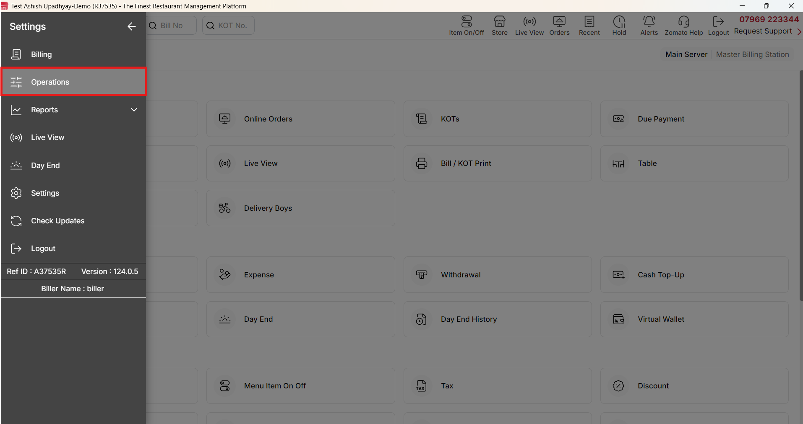
{ Image Name: Operation in POS,
Description: The highlighted section indicates the Operation in POS system where users can configure multiple configuration This is Step 1 to Find IP in POS System }

Step 2 : Click on Settings
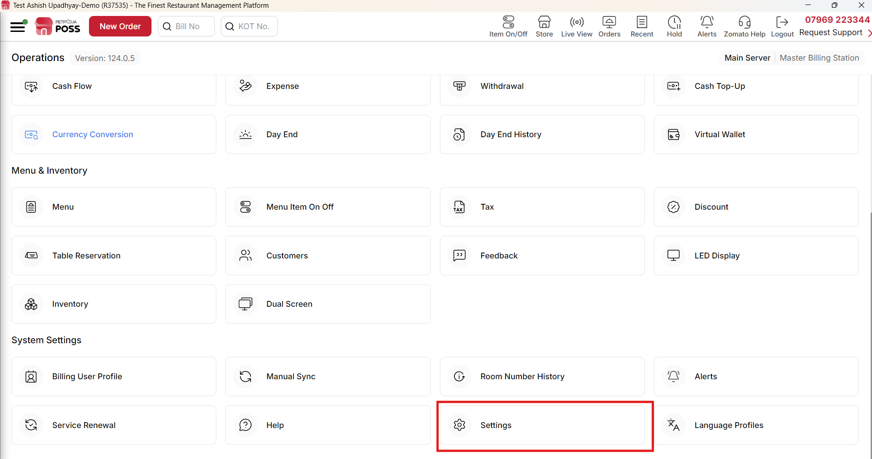
{ Image Name:Settings in POS,
Description: The highlighted section indicates the Settings option in POS System where users can configure multiple configuration, This is Step 2 to Find IP in POS System }

Step 3: Click on Check Machine Options in POS System
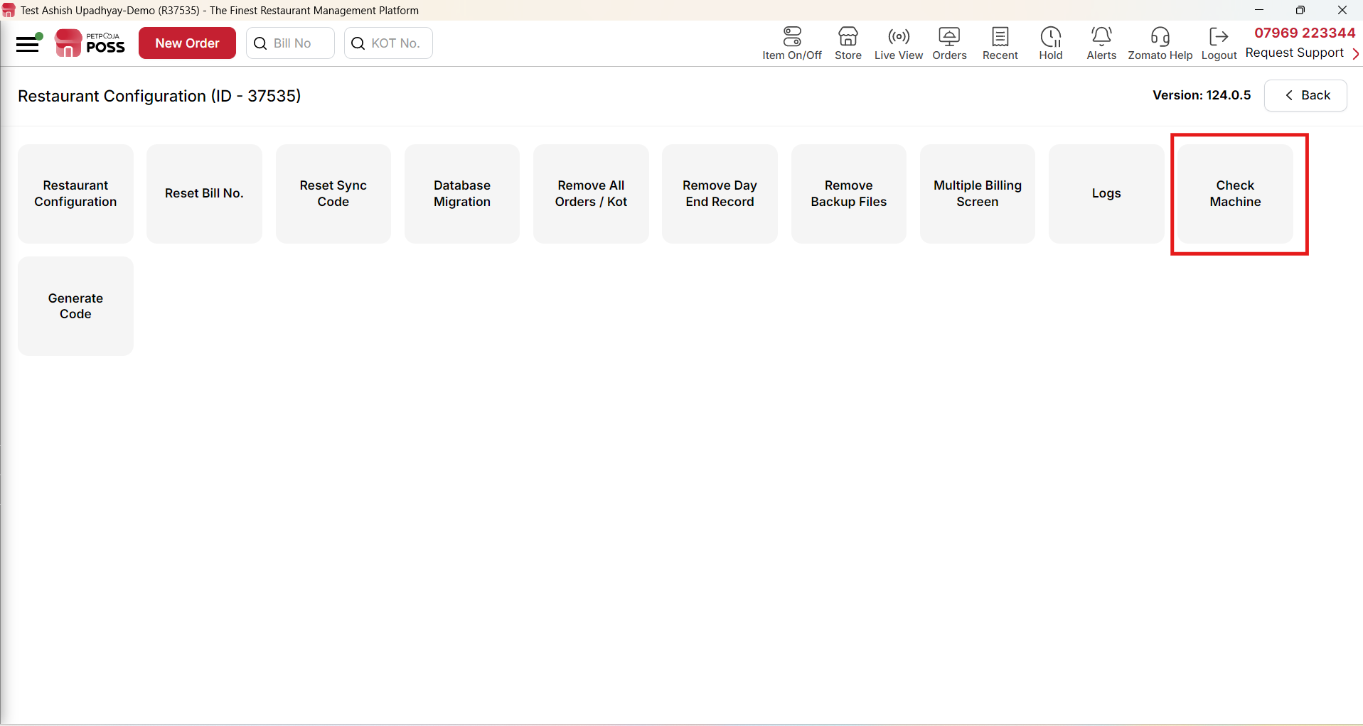
{ Image Name: Check Machine in POS,
Description: The highlighted section indicates the Check Machine option in POS System where users can check IPs of Server as well as client system. This is Step 3 to Find IP in POS System }

Step 4: Under Main server section find IP address of the server System
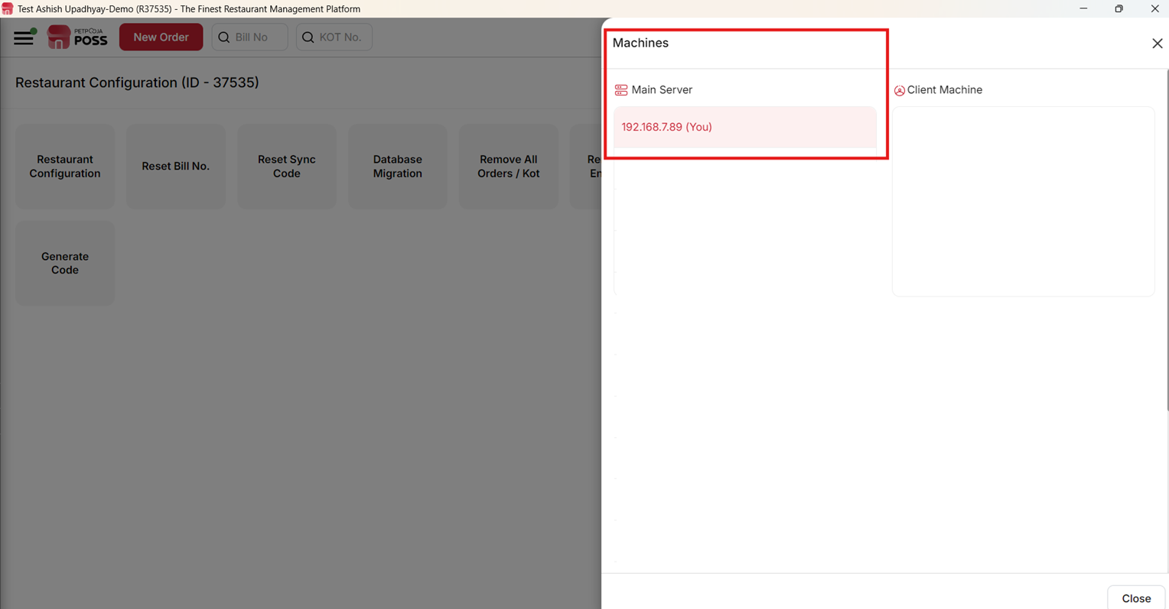
{ Image Name: Main Server IP,
Description: The highlighted section indicates the Main Server IP address. This is Step 4 and final steps to Find IP in POS System }

Troubleshooting
- New Items Not Showing in the Captain App: When new items are added from the main dashboard, they do not automatically appear in the Captain app. This occurs because the app requires manual synchronization to fetch the latest changes from the server. By forcing an update within the app, the local menu data will refresh, and all recently added items will become visible.
Step-by-Step Resolution
Follow these instructions to sync your data and display the new items:
- Open the Captain app on your device.
- Tap the Sidebar icon to open the main navigation panel.
- Select the Update menu option.
- Wait a few moments for the data synchronization to complete.
- Return to the main screen to verify that the newly added items are now visible.

